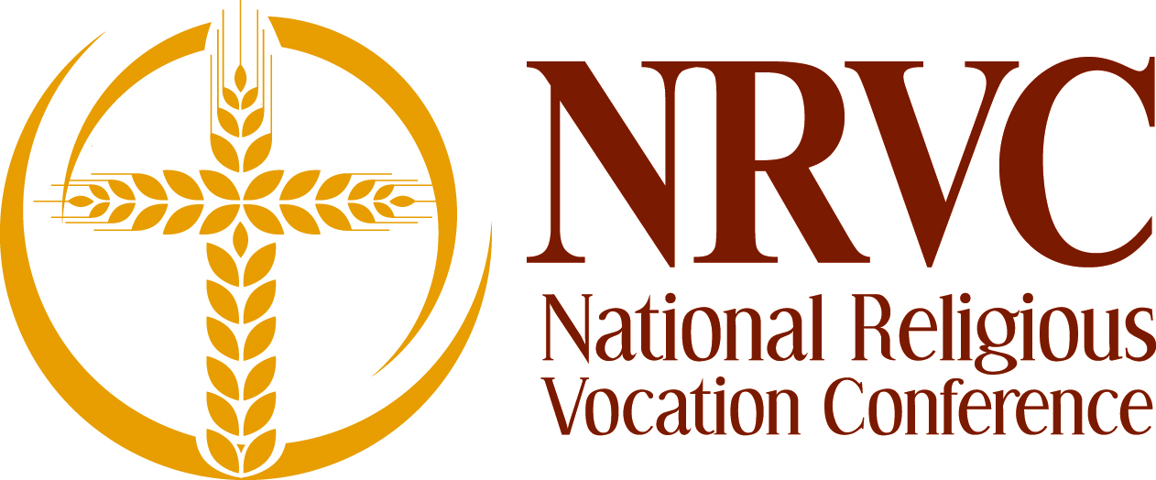

Application requirements for NRVC executive director

Applicants should:

    - meet the eligibility requirements contained in the executive director job description;
    - provide a resume;
    - submit four letters of reference – two personal; two professional;
    - provide a letter of suitability and permission from Major Superior;
    - provide copies of transcripts
    - submit an application essay answering the following questions:
      - What is your vision for NRVC?
      - What skill set do you bring to the position of NRVC executive director?
    - be willing to offer a 3-5 year commitment.

Please send materials by December 16, 2016 to:

Search Committee
National Religious Vocation Conference
5401 S. Cornell, Suite 207
Chicago, IL 60615;

Or email NRVC board chair Brother Ronald Hingle, S.C. at rhinglesc@gmail.com.

